Design Your Vertical Farm: Lettuce
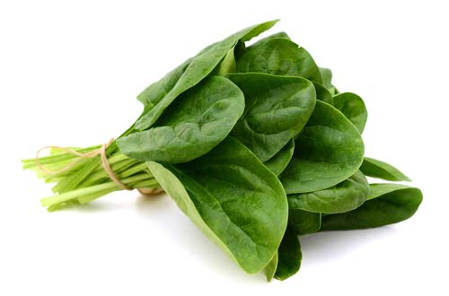

Spinach is a leafy green vegetable that grows quickly and is rich in vitamins, often used in salads and cooking

 | Water
 | Oxygen
 | Nutrition
 | Sensitivity
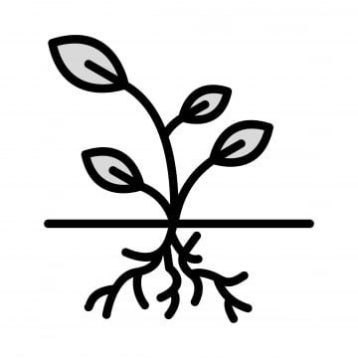 | Roots depth
Special: Sensitivity to heat

Now, based on provided information, design your own vertical farm for the spinach
Your Vertical Farm Here!

