Design Your Vertical Farm: Lettuce
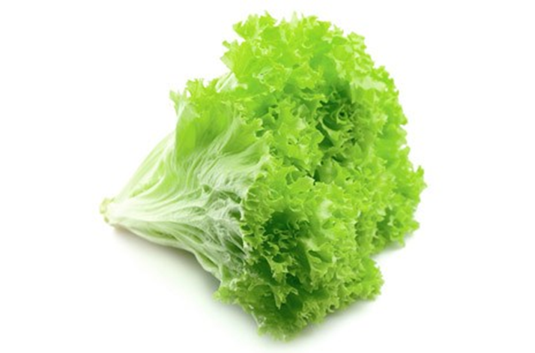

Lettuce is a leafy green vegetable, typically eaten raw in salads, but also used in sandwiches, wraps, and soups.

 | Water
 | Oxygen
 | Nutrition
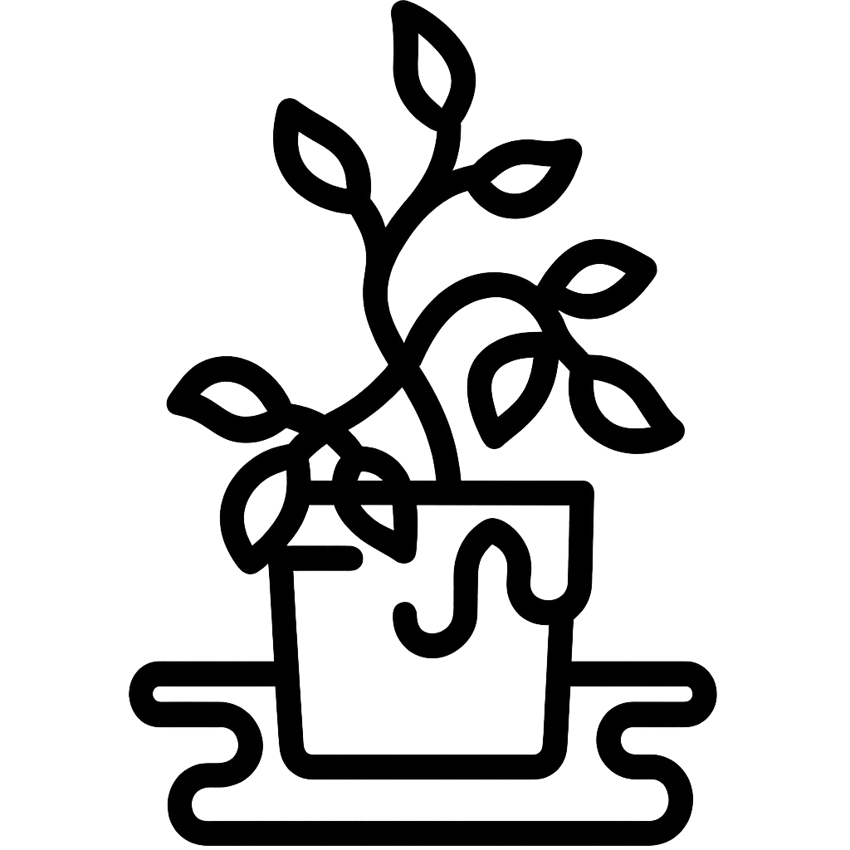 | Sensitivity
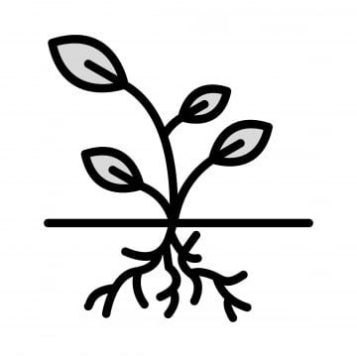 | Roots depth
Special: Temperature sensitivity

Now, based on provided information, design your own vertical farm for the lettuce
Your Vertical Farm Here!

